Chapter 14, Solution 20.

Design a more complex problem than given in Prob. 14.10, to help other students to better understand how to determine the Bode magnitude and phase plots of a given transfer function in terms of jω. Include at least a second order repeated root.

Although there are many ways to solve this problem, this is an example based on the same kind of problem asked in the third edition.

Problem

Sketch the magnitude phase Bode plot for the transfer function

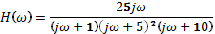

Solution
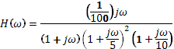

20log(1/100) = -40

For the plots, see the next page.
The magnitude and phase plots are shown below.
1
0.1
5
10
50
100
ω
40
20 log
20 log
20 log
20
-40
-20
-60
20 log
20 log

1
0.1
5
10
50
100
ω
180˚
(1+jω/5)²
jω
90˚
–180˚
–90˚
–270˚
(1+jω)
(1+jω/10)

